Document Title | Document Code | Document Type | Issue No | Sop No.
New Feature Request | S-SW-FR | SOP | 01 | 2
Issue Date | Effective Date | Copy No. | Revision No.
01/10/2025 | 01/10/2025 | Master | 0

Purpose
Standardize the intake, evaluation, development, and deployment of new feature requests to ensure alignment with business goals, efficient resource utilization, and stakeholder satisfaction.

Procedure & Flow
Step 1: Request Intake
- Action:
  - Stakeholders submit requests via Request form (business case, expected outcomes).
  - Request Form (business case, expected outcomes) by End User or Stakeholder.
  - Request Meeting in Minutes Form by Business Analyst.
  - Requirements List Form by Business Analyst, Software Supervisor and Software Manager.
  - Requests Log Form by Software Manager & Software Supervisor.
  - High-Level Design (SRS, BRD, TFS) by Business Analyst.
  - Required fields: Priority (P1 > P4), impacted subsidiaries.
- Roles:
  - Subsidiary Liaison/Internal Stakeholder: Logs request.
  - Shared Service Coordinator (Software Supervisor): Assigns tracking ID.
Step 2: Technical Feasibility & Scoping
- Action:
  - Technical Team (Software Supervisor, Business Analyst, Developers, Tester, UI/UX Designer) assesses:
    - Technical complexity
    - Integration points
    - Resource requirements
- Output: High-Level Design document.
- Roles:
  - Software Supervisor & Business Analyst: Leads assessment.
  - Software Manager: Approves High-Level Design.
- Timeline: ≤10 business days.
Step 3: Prioritization & Roadmap Alignment
- Action:
  - Review by Feature Review Board (Software Manager, Business Analyst/Product Owner, Subsidiary Representer).
  - Prioritize using TFS.
- Roles:
  - Software Manager: Final prioritization.
Step 4: Agile Development
- Action:
  - Break into user stories; assign to sprints.
  - Bi-weekly stakeholder demos.
- Roles:
  - Business Analyst: Creates user stories.
  - UI/UX Designer: Translates needs into interfaces.
  - Developers Team: Implements features.
  - Software Tester: Continuous validation.
Step 5: Release & Adoption Tracking
- Action:
  - Deploy via phased rollout (Software Supervisor).
  - Monitor adoption via usage analytics (Software Supervisor).
- Roles:
  - Software Supervisor: Manages deployment.
Documents & Records
- Request Form by End User or Stakeholder.
- Request Meeting in Minutes Form by Business Analyst.
- Requirements List Form by Business Analyst, Software Supervisor and Software Manager.
- Requests Log Form by Software Manager & Software Supervisor.
- High-Level Design (SRS, BRD, TFS) by Business Analyst.
- Prioritization Matrix by Technical Team.
- Retrospective Meeting Form by Technical Team.

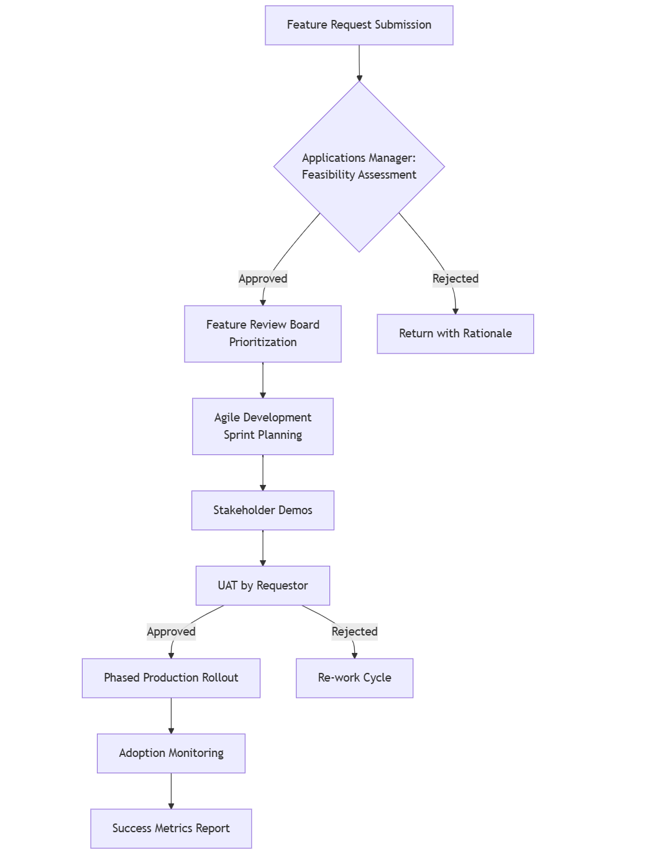

Forms
Form Name | Form Code
Service Request Form | F-SW-FR/01
Request Meeting in Minutes Form | F-SW-FR/02
Requirements List Form | F-SW-FR/03
Requests Log Form | F-SW-FR/04
Retrospective Meeting Form | F-SW-FR/11
Product Backlog TFS
Sprint Backlog TFS
Task TFS

Revision History
Rev No | Rev Date | Issue No | Issue Date | Description of Change | Approved By
0 | 01-10-2025 | 01 | 01-10-2025 | Initial Issue

